DIGITAL CLOCK

LED 7-Segment Display

Using Arduino Nano | Multiplexing | Manual Time Control
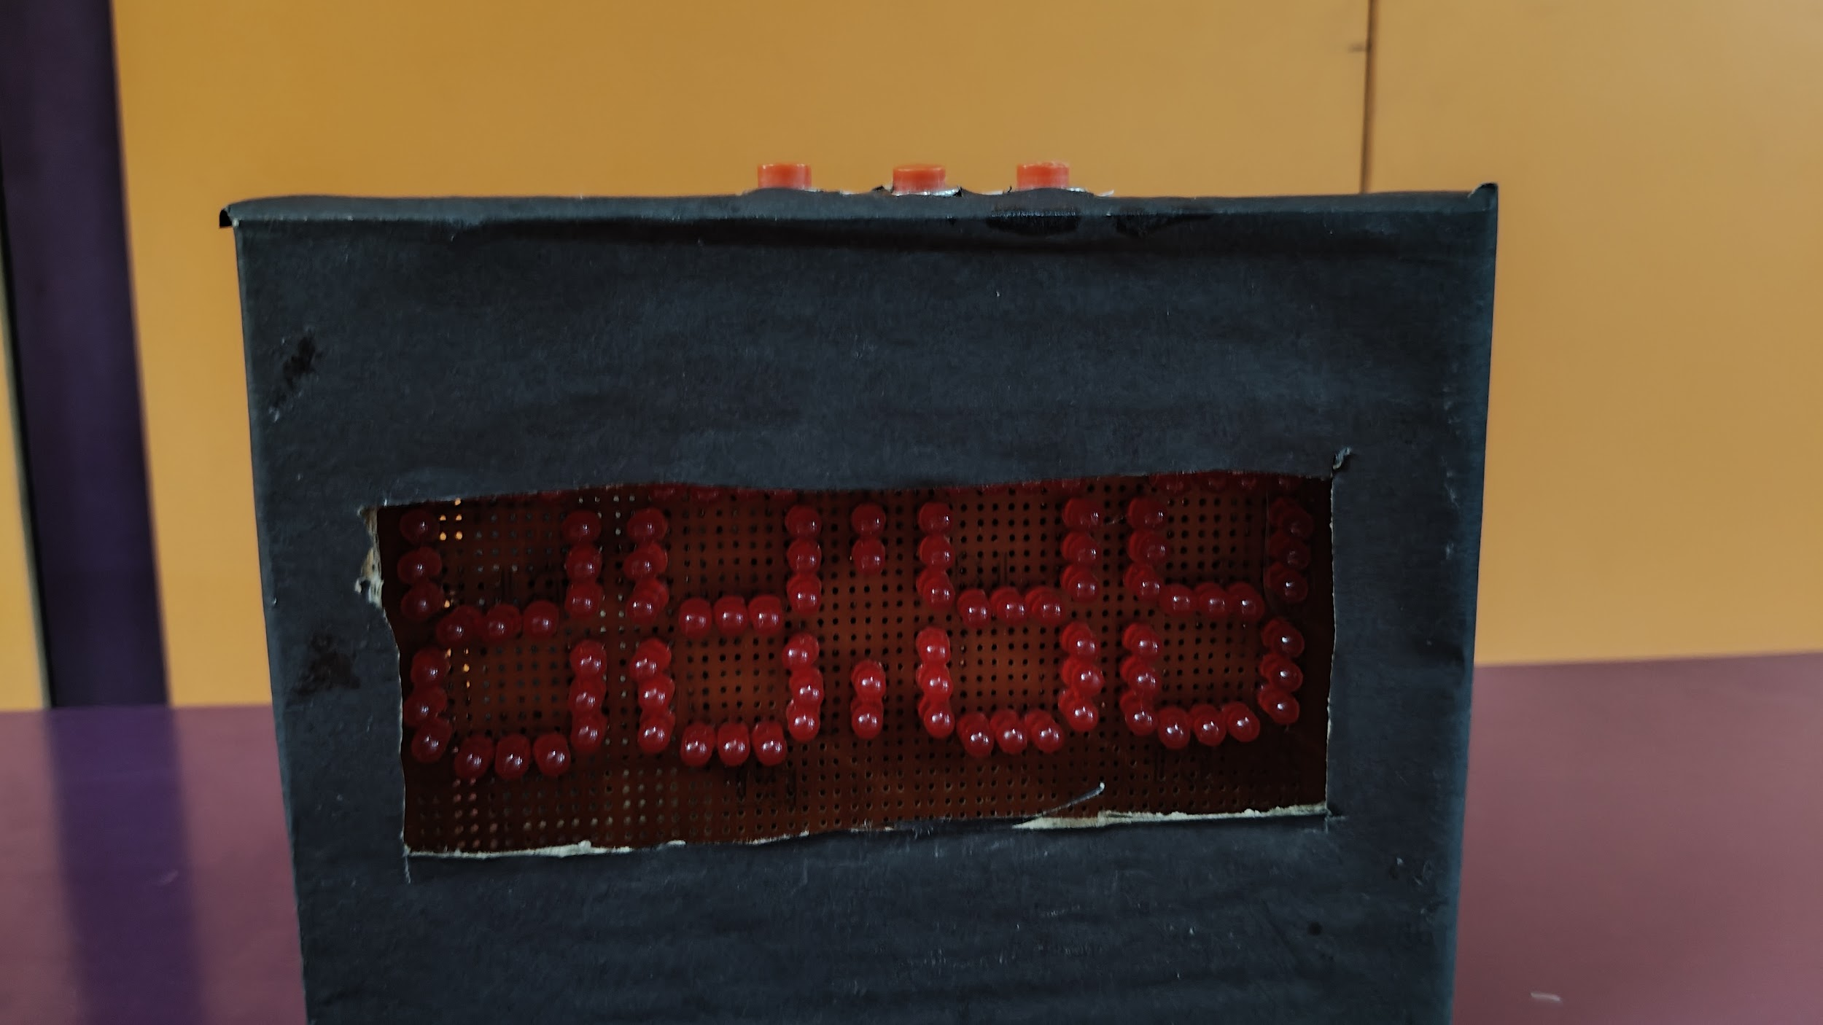
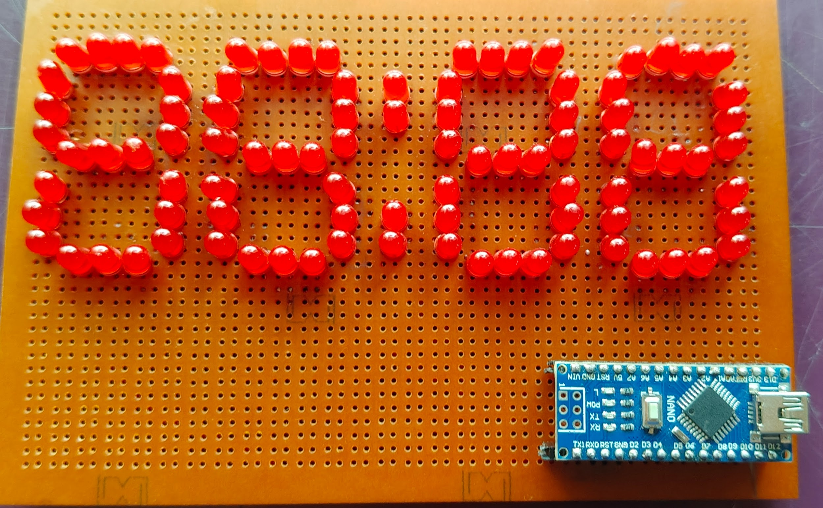
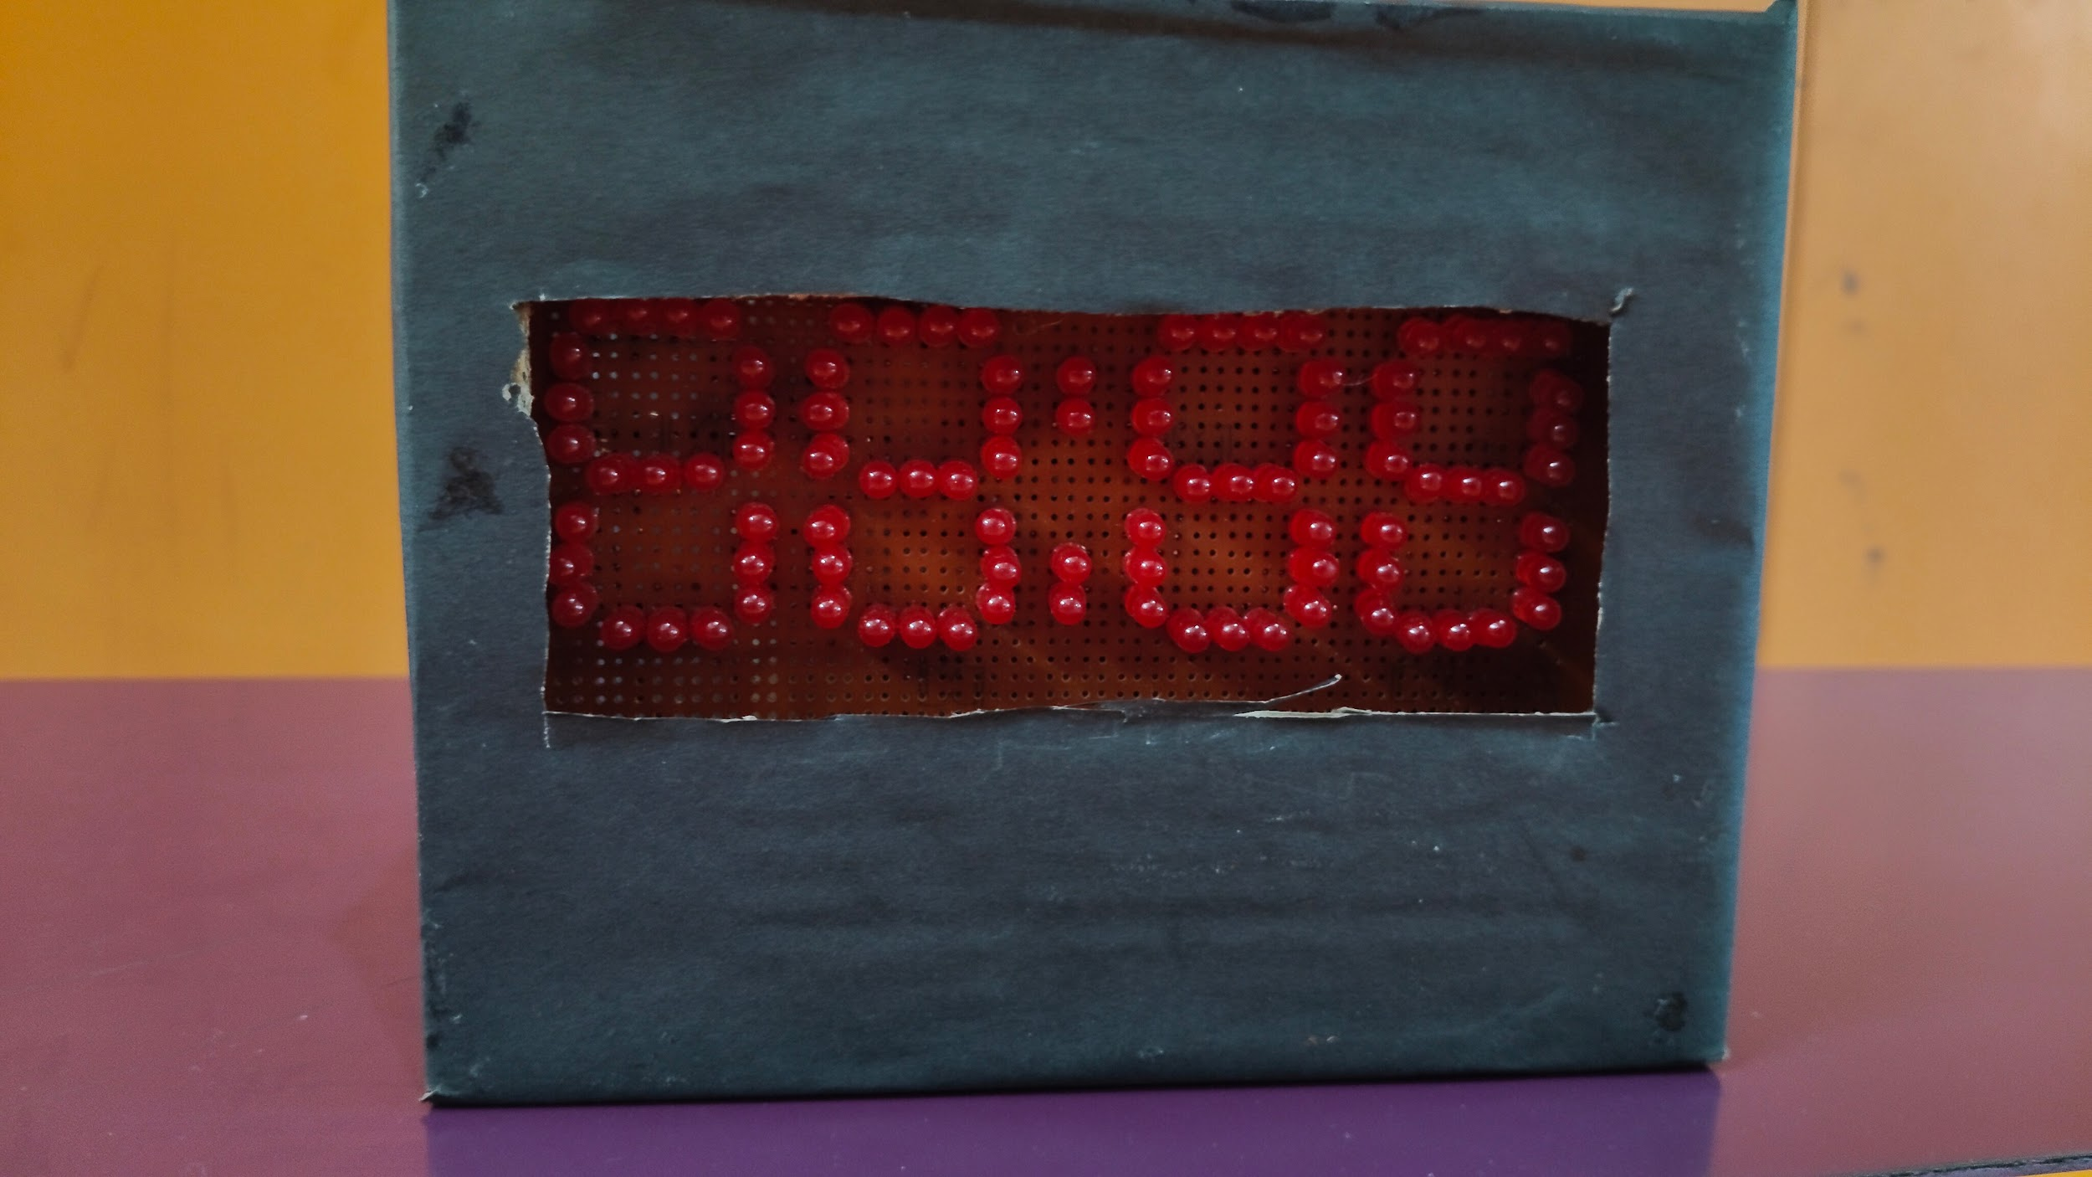

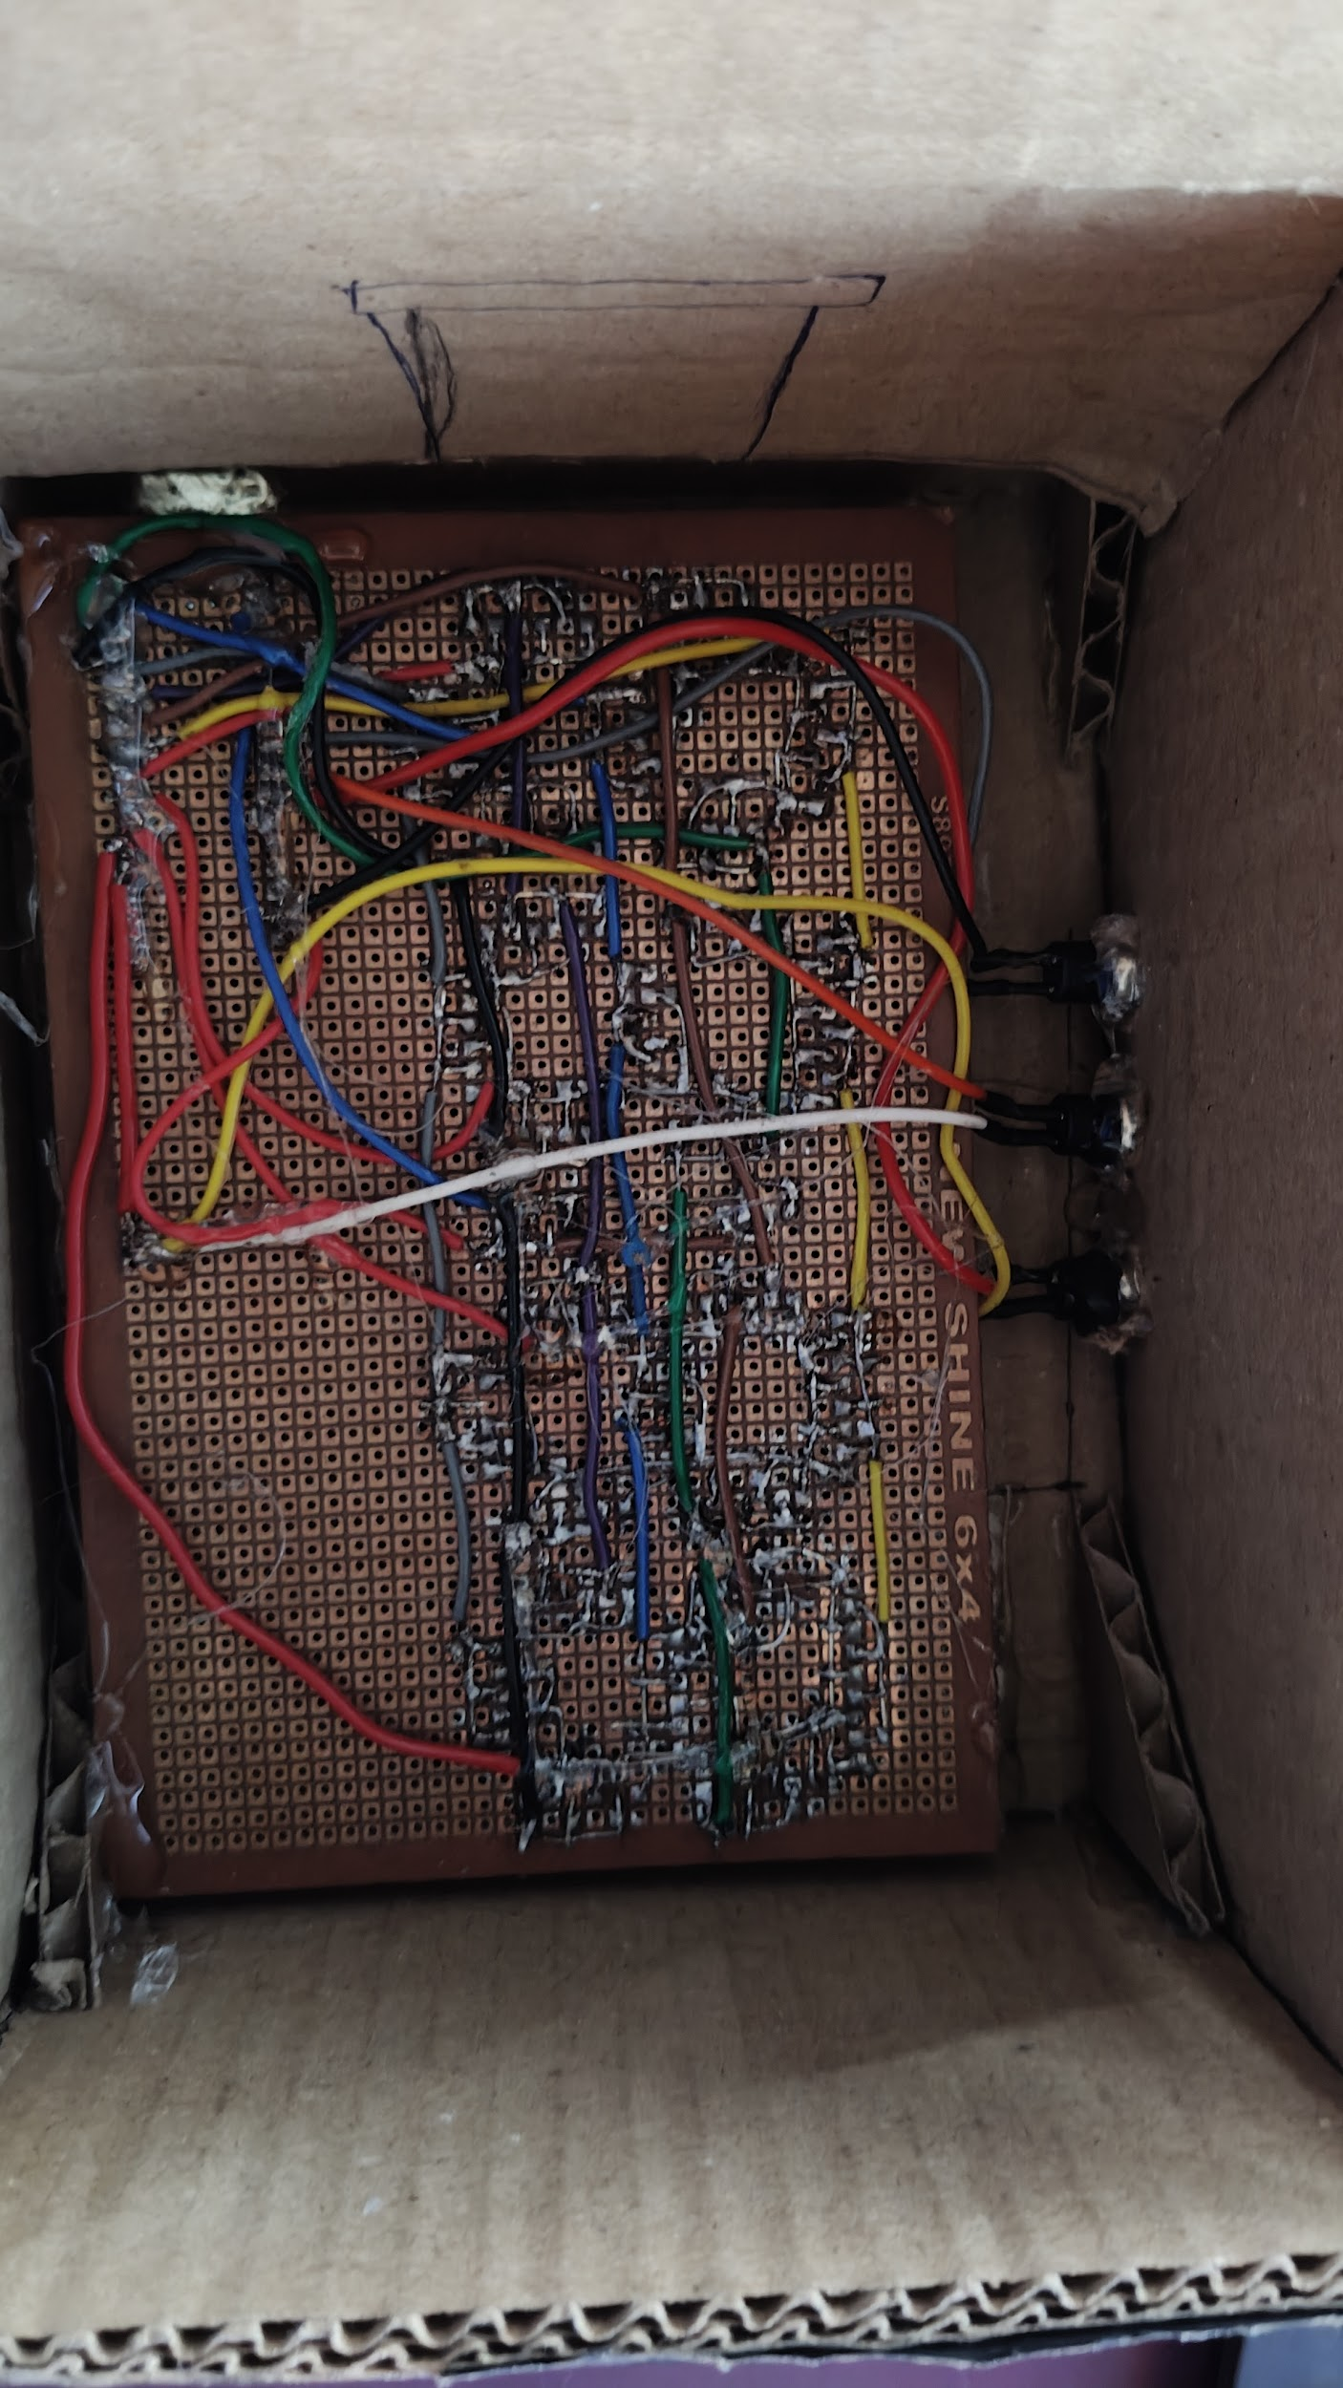

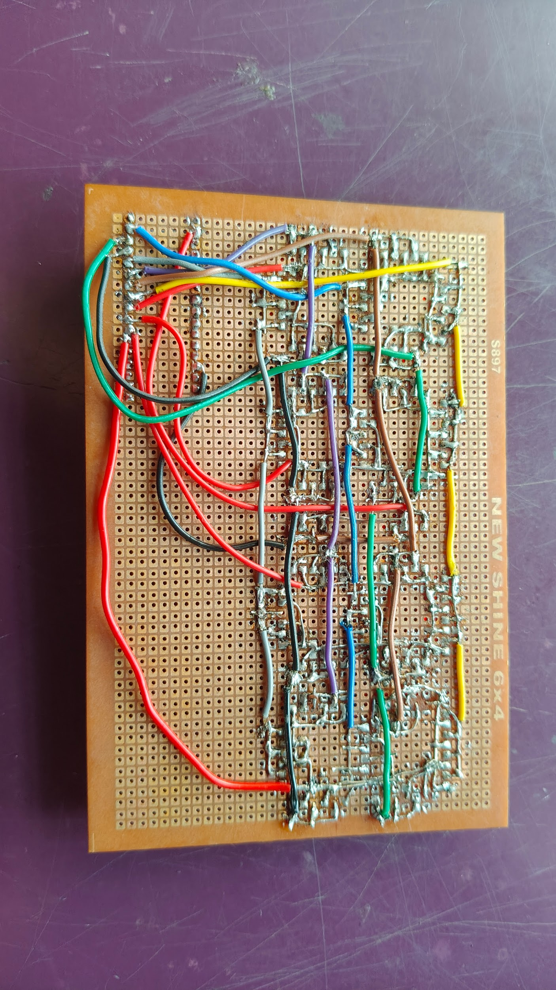

1. Project Overview
This project demonstrates a fully functional digital clock built using discrete red LEDs arranged as custom 7-segment displays on a prototype PCB (dot PCB). Each digit of the clock is formed by illuminating specific LED segments, replicating the classic 7-segment numeral pattern.
An Arduino Nano controls all display segments using multiplexing, rapidly refreshing each digit so the human eye perceives continuous illumination.
The clock displays hours:minutes in HH:MM format and includes push-button controls for manual time setting.
The complete display was handmade using 92 red LEDs:
- 88 LEDs for the 4-digit display
- 4 LEDs for the dual blinking colon indicators

2. System Components
Component | Specification | Qty | Purpose
Arduino Nano | ATmega328P, 5V, 16MHz | 1 | Main controller & timekeeping
Red LEDs | 5mm LEDs | 92 | Display segments & colon indicators
Prototype PCB / Dot PCB | Copper board | 1 | Mounting & soldering
Push Buttons | Momentary SPST | 3 | Mode / Time control
Wires |  | As required | Connections
USB Power Supply | 5V | 1 | Power source

3. 7-Segment Display Theory
A standard 7-segment display uses seven LED segments labelled A through G. By illuminating different combinations of these segments, decimal numbers from 0 to 9 can be displayed.

Segment Layout
- Segment A → Top horizontal
- Segment B → Top-right vertical
- Segment C → Bottom-right vertical
- Segment D → Bottom horizontal
- Segment E → Bottom-left vertical
- Segment F → Top-left vertical
- Segment G → Middle horizontal
The display uses a common-anode multiplexed configuration.

4. How Multiplexing Works
Driving four digits independently would normally require a large number of Arduino pins. Multiplexing reduces pin usage by sharing segment lines across all digits and enabling only one digit at a time.
The Arduino rapidly cycles through:
- Enable one digit
- Send segment data
- Disable digit
- Move to next digit
This process repeats continuously at high speed, creating the illusion that all digits are ON simultaneously.

5. Circuit & Pin Connections

Digit Pins
Arduino Pin | Connected To | Function
D2 | Digit 1 | Hours Tens
D3 | Digit 2 | Hours Units
D4 | Digit 3 | Minutes Tens
D5 | Digit 4 | Minutes Units

Segment Pins
Arduino Pin | Segment
D6 | Segment A
D7 | Segment B
D8 | Segment C
D9 | Segment D
D10 | Segment E
D11 | Segment F
D12 | Segment G

Colon Indicator
Arduino Pin | Function
D13 | Colon LEDs

Push Buttons
Arduino Pin | Function
A3 | MODE
A4 | UP
A5 | DOWN

6. Working Principle
The Arduino Nano continuously refreshes the multiplexed display while maintaining software based timekeeping using the millis() timer function.
The clock operates in three modes:
- Normal Clock Mode
- Hour Edit Mode
- Minute Edit Mode
The MODE button cycles through these states:
- Normal → Hours → Minutes → Normal
The UP and DOWN buttons are used to adjust the selected time value.
The blinking colon LEDs act as a visual seconds indicator.

7. Button Functions
Button | Function
MODE | Enter setting mode / switch between hours and minutes
UP | Increase selected value
DOWN | Decrease selected value

8. Software Logic
The program uses:
- Multiplexing for display control
- millis() based timing system
- Internal pull-up resistors for button inputs
- State based mode switching
- Manual time editing system
While in edit mode, the clock pauses time counting until the user exits back to normal mode.

9. Technical Specifications
Parameter | Value
Microcontroller | Arduino Nano
Display Type | Custom LED 7-Segment
Display Format | HH:MM
LED Count | 92 Red LEDs
Display Configuration | Common Anode
Supply Voltage | 5V DC
Timekeeping Method | Software millis()
User Interface | Push Buttons
Board Type | Prototype PCB / Dot PCB

10. Advantages
- Large custom display design
- Low cost implementation
- Hands-on multiplexing experience
- Fully repairable LED structure
- Expandable architecture
- Educational embedded systems project
- Customizable display size and color

11. Applications
- DIY digital clocks
- Embedded systems learning
- Electronics project demonstrations
- Multiplexing experiments
- Educational Arduino projects

12. Future Improvements
- Add RTC module for accurate timekeeping
- Add alarm functionality
- Add brightness control using PWM
- Add battery backup
- Add WiFi time synchronization
- Design custom PCB
- Add temperature display mode

13. Final Conclusion
This project demonstrates how a fully functional digital clock can be built using discrete LEDs, multiplexing techniques, and embedded programming concepts.
By combining custom hardware construction with software controlled display management, the project provides practical understanding of:
- LED segment encoding
- Multiplexing
- Timekeeping
- Push button interfacing
- Real-time embedded systems
The handmade prototype PCB construction and large custom LED display make the project both visually appealing and educationally valuable.

